***A***

***PROJECT REPORT ON***

***“Educational Course Finder”***

Submitted to

**Punyashlok Ahilyadevi Holkar Solapur University,**

**Solapur.**

In Partial Fulfilment Of The Degree

**“BACHELOR OF COMPUTER APPLICATION”**

**(BCA-III)**

Submitted By

**Miss. Fiza Shaikh (1720)**

**Miss. Sanskruti Upare(1727)**

**PRIN.K.P.MANGALVEDHEKAR INSTITUTE OF MANAGEMENT, CAREER DEVELOPMENT AND RESEARCH, SOLAPUR.(KPMIM)**

**2021-2022**

***CERTIFICATE OF DIRECTOR***

This is to certify that the project entitled,

“Educational Course Finder”

Has been satisfactorily completed by

**Miss. Fiza Shaikh (1720)**

**Miss.Sanskruti Upare(1727)**

In The Partial Fulfilment of the Three Year Degree Course,

**“BACHELORE OF COMPUTER APPLICATION” (BCA-III)**

Submitted to,

**Punyashlok Ahilyadevi Holkar Solapur University, Solapur.**

Under the guidance of

**Mrs. Nilima Mondhe**

Same is hereby approved for the year

2021-2022

Place: Solapur Director:

Date: / /2022

***CERTIFICATE OF HOD***

This is to certify that the project report entitled,

“Educational Course Finder”

Has been satisfactorily completed by

Miss. Fiza Shaikh (1720)

Miss. Sanskruti Upare (1727)

In The partial Fulfilment of the Three Year Degree Course,

**“BACHELOR OF COMPUTER APPLICATI0N” (BCA-III)**

Submitted to,

**Punyashlok Ahilyadevi Holkar Solapur University, Solapur.**

Under The Guidance Of

**Mrs. Nilima Mondhe**

same is hereby approved for the year

2021-2022

Place: Solapur Director:

Date: / /2022

**CERTIFICATE OF GUIDE**

This is to certify that the project report entitled

“**Educational Course Finder**”

Has been satisfactory completed by

**Miss. Fiza Shaikh(1720)**

**Miss. Sanskruti Upare(1727)**

In the Partial Fulfilment of the Three Year Degree Course of,

**“BACHELOR OF COMPUTER APPLICATION” (BCA-III)**

Submitted to,

**PunyashlokAhilyadevi Holkar Solapur University, Solapur.**

Under The Guidance Of

**Mrs. Nilima Mondhe**

And to the best of my knowledge and belief, that matter presentation this report has not been submitted earlier.

Place: Solapur Sign of Project Guide:

Date: / /2022

**DECLARATION**

We undersigned here by declaring that the project report entitled,

**“Educational Course Finder”**

Written and submitted by us and it is our original work and is done under the guidance of **Ms. Nilima Mondhe**

The Empirical Findings in this report are

based data collection by us

While preparing this, we have not copied from any report and Website.

We understand that any such copying is entitled to be punished in a way that university authorities deem to be fit.

**Sign Of Students:**

Place: Solapur

Date: / /2022

**Ms. Fiza Shaikh(1720)**

**Ms. Sanskruti Upare(1727)**

**ACKNOWLEDGMENT**

A word thanks is much less for the word encouragement which we have received from people going out of the way to make us feel comfortable and to make the things simple. From the bottom of my heart I would like to Thank the director of the institute **Mr. Pramod Vaidya Sir** And to the HOD of the Computer Department **MR. Santosh Kulkarni Sir** who has given me opportunity to submit this project.

My special Thanks and Sincere gratitude go to our guide **Mrs.Nilima Mondhe Madam** who helped me a lot in making this Project. Without her constant guidance and constructive Criticism throughout the project, it would not have been possible.

**Place: Solapur Student’s Signature:**

**Date:** / /2022

**Miss. Fiza Shaikh(1720)**

**Miss. Sanskruti Upare(1727)**

**INDEX**

|  |  |  |
| --- | --- | --- |
| **Sr.No** | **TOPIC** | **Page No.** |
| 1 | INTRODUCTION |  |
|  | 1.1 Project Overview |  |
|  | 1.2Present System |  |
|  | 1.3Proposed system |  |
|  | 1.4 Scope of the Project |  |
| 2 | FEASIBILITY STUDY |  |
|  | 2.1 Project Feasibility |  |
|  | 2.2 Hardware Specification |  |
|  | 2.3 Software Specification |  |
| 3 | SYSTEM DESIGN |  |
|  | 3.1 DFD |  |
|  | 3.2 ERD |  |
|  | 3.3 Database Design |  |
|  | 3.3 Output Screen |  |
| 4 | TESTING |  |
| 5 | USER MANUAL |  |
| 6 | LIMITATION |  |
| 7 | BIBLOIGRAPHY |  |

**INTRODUCTION OF PROJECT**

* 1. **Existing System:**

Previously organization was doing all the working manually but at present, computers are becoming part of every activity in organization. The more common and obvious application are business applications.

So with the time, the system must also fit into a competitive environment and must be very easy to use. Above all, the main goal of computer based information system is to speed up the processing. And that is the reason why the new system was proposed.

1. The operation of course Finder still now is maintained in the manual system.

2. The operation is tedious, time consuming and space consuming.

3. It creates room of errors as the package and date is entered manually by the person.

4. It includes the risk of the document being lost over years and maintenanceof the records is difficult.

5. The data recorded during testing or while acquiring the details of different aspects of course finder is not accurate and precise.

1.2)**Proposed System:**

The aim of proposed system is to develop a system of improved facilities.

The proposed system can overcome all the limitations of the existing system. The system can overcome all the limitations of the existing system. The System provides proper security and reduces the manual work.

This system is interactive and user-friendly desktop application. The application is developed using Microsoft visual studio 13 as a front end and SQL server as a back end to accommodate all the future of GUI technology such as Text Box, Combo Box Buttons which will be multi user system.

In today’s dynamic and highly competitive marketplace, this system will help to achieve productivity, profitability, and growth.

* Security of data.
* Ensure data accuracies.
* Minimize manual data entry.
* Minimum time needed for the various processing.
* Greater efficiency.
* Better service.
* User friendliness and interactive.
* Minimum time required.

**1.3: Scope of Project**:

It may help collecting perfect management in details. In a very short time, the collection will be obvious, simple and sensible.It will help a person to know the management of passed year perfectly and vividly. It also helps in current all works relative to courses and course Finder. It will also helps in current all works relative to courses and course finder .It will be also reduced the cost of collecting the management and collection procedure will go on smoothly. Our project aims at business process automation , i.e. we have tried to computerize various processes of package and Billing system.

1. In computer system the person has to fill the various forms & number of copies of the forms can be easily generated at a time.
2. In computer system, it is not necessary to create the manifest but we can directly print it which saves our time.
3. To assist the staff in capturing the effort spent on their respective working areas.
4. To utilize resources in an efficient manner by increasing their productivity through automation.
5. The system generates types of information that can be used for various purposes.
6. It satisfy the user requirement.
7. Be easy to understand by the user and operator.
8. Be easy to Operate.
9. Have a good user interface.

10.Be expandable.

**OBJECTIVE OF THE PROJECT:**

The main objective of the project on course finder is to manage the details of student Registration, college Registration, Details of course and college .

It manages all the information about course. The project is totally built at administrative end and thus only the administrator is guaranteed the access.

The purpose of the project is to built an application program to reduce the manual work for managing the Records, Registration. It tracks all the details about the college , course and the student details.

Functionalities provided by the course finder are as follows:

1. Course Finder also manages the Record details for forms.

2. It tracks all the information of student, college and course etc.

3. Shows the information and description of the college and course.

4. To increase efficiency of managing the Records of the form.

5. Manage the information of course , college and student.

6. Deleting , Adding new records and updating of Records in improved which results in proper resource management of forms of course.

**FEASIBILITY STUDY**

**Introduction:-**

The preliminary investigation tells us whether the system that we are Developing is practical or not. The feasibility study helps in that matter. Feasibility study is a very important stage in the system development. It helps to obtain an overview of the problem and to get rough assessment of whether feasible solutions exist. It can define problems, objectives involved in the project.

Followings are Three Types of Feasibility Study:

1. Technical feasibility.

2. Economical Feasibility.

3. Operational Feasibility.

**1.Technical Feasibility:**

Technical feasibility is carried out to know whether the new system can be done with present equipment, existing software technology. All the present technologies, whether those are sufficient or not to develop new system is decided Ideally, the system should be compatible with the available Hardware and Software, or should work with very little up-gradation, to be considered as a feasible system.

Minimum Hardware Requiretment

The minimum Hardware Requiretment for this website is: 1.Processor: Intel Processor.

2.Ram:-1GB(recommended)

3.Hard Disk:-10 GB.

4.Monitor:-Standard.

5.Keyboard & Mouse.

Mininum Software Requirement

The minimum software requirements used for this website are:

Front End: Microsoft visual Studio 2013

Back End: MS SQL Server 2012

**2.Economical Feasibility:**

It is related to cost analysis. In the proposed system, there is no need to Buy additional hardware or software. Banks only need to store documents and quick search out that Document which they wants to see. Manager need to update the Progress Report of documents.

**3.Operational Feasibility:**

Operational feasibility is carried out to see the effects after the system is implemented. This windows development system is very user friendly so user. Also provide easy and fast access to their reports.

**PROJECT DEVELOPMENT PLAN**

For developing Tooling Management minor software project work. I have chalked out the project development plan as:

Project Initiation: January 2020

|  |  |
| --- | --- |
| **Task** | **Day to Complete(Approx)** |
| Initial Discussion | 5 |
| Study of Tools | 5 |
| Analysis | 10 |
| Module Design ,menu ,Toolbar ,Interface design | 10 |
| Screens | 10 |
| Construction | 10 |
| Testing | 5 |
| Documentation | 5 |

**SYSTEM ANALYSIS**

**FACT FINDING ANALYSIS:**

Fact finding is a process of gathering data and information through number of techniques. The various fact finding techniques are:

Document Review:

We observed that which type of documents or information they maintain about course details so that we can easily design our system which is exactly needed by the user.

Interview:

We visited the site to collect the information through face to face interactions the interview of student were taken to understand what type of website and which type of data should be maintained by the system .From this we have:

1)Identified the requirments.

2) New ideas and opinions.

3) Verified and cleared the facts.

Questionaries:

Questions must be well organized from the point of view of respondent. The question were being asked in fixed format the facts and opinions were been collected from student point of view.

**OBJECT ORIENTED ANALYSIS/STRUCTURED ANALYSIS**

**DATA FLOW DIAGRAM**

**Context level or zero level Diagram**

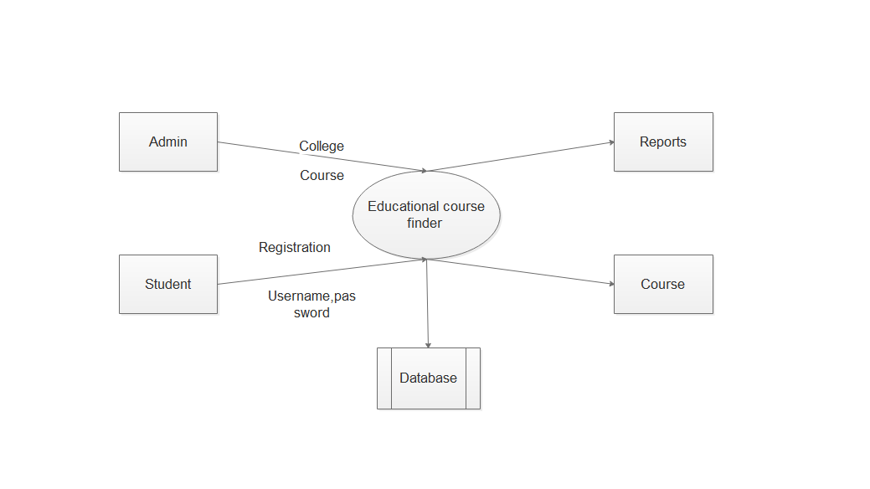

**Second level DFD**

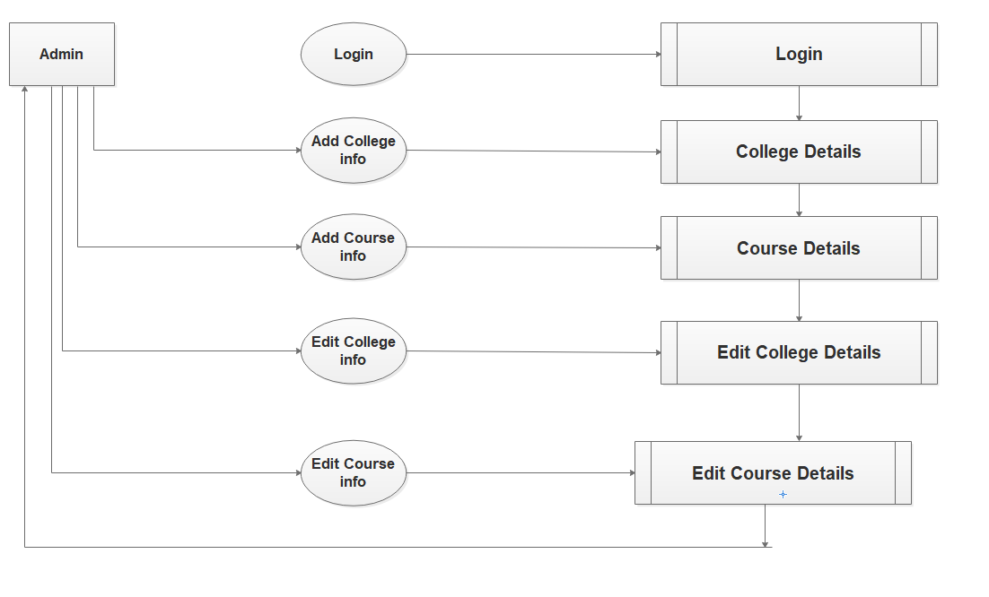

**Final level DFD**

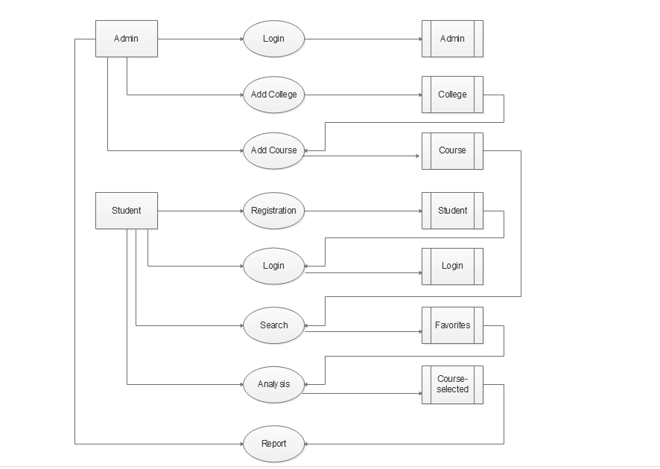

**ERD**

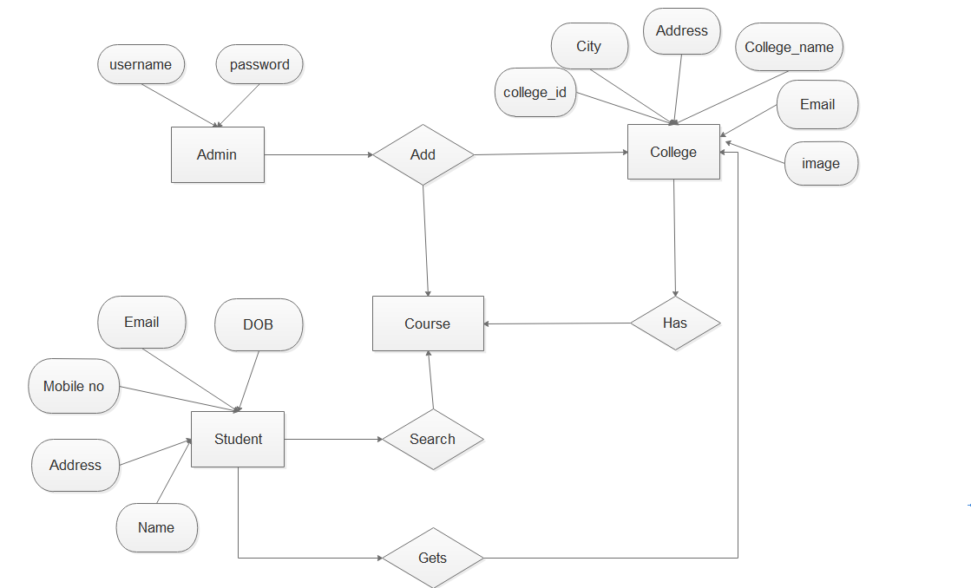

**Database Design**

**1)Login Table:**

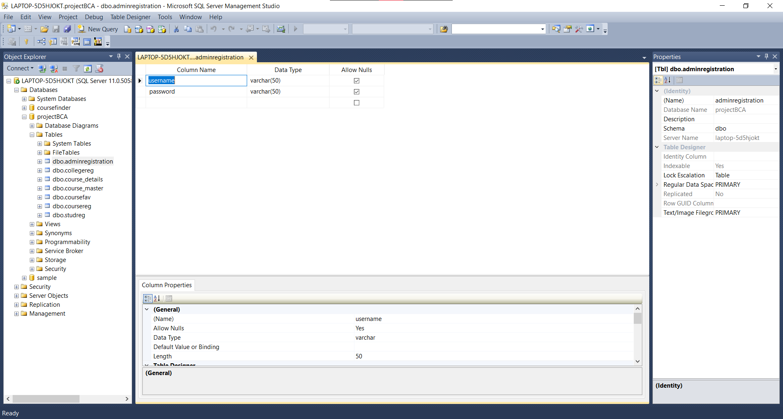

**2)Student Registration Table:**

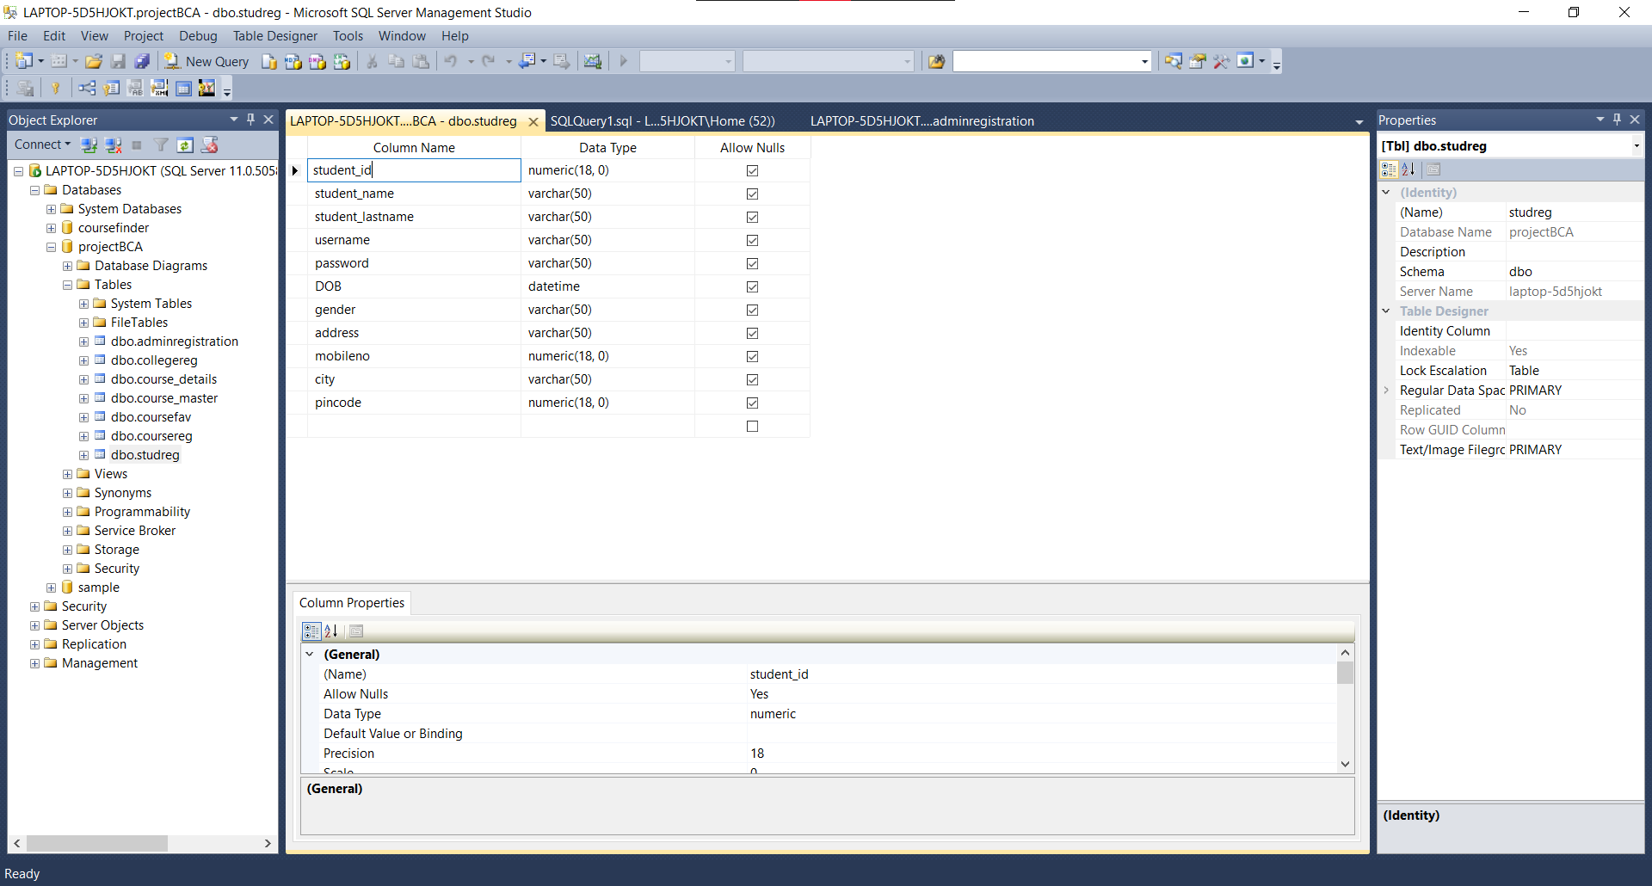

**3)Admin Registration Table:**



**4)College Registration Table:**

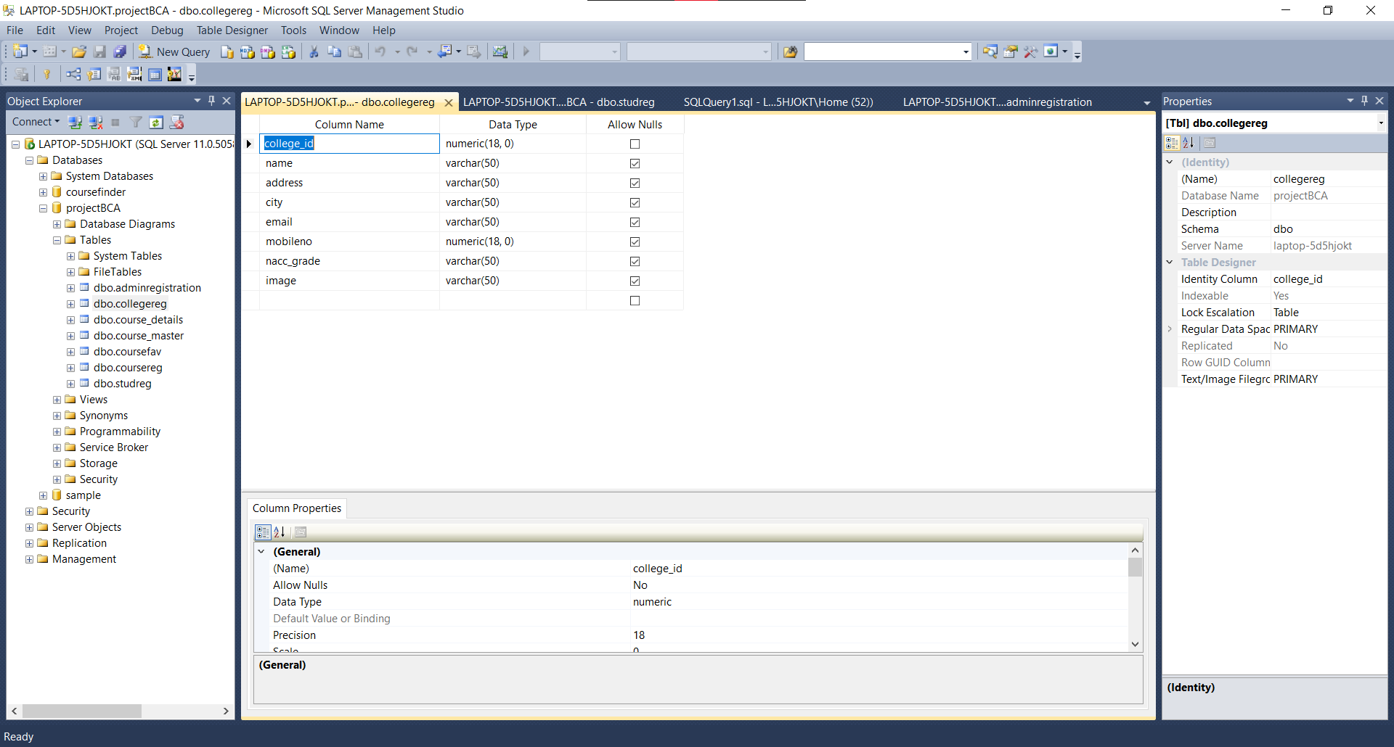

**5)Course Registration Table:**

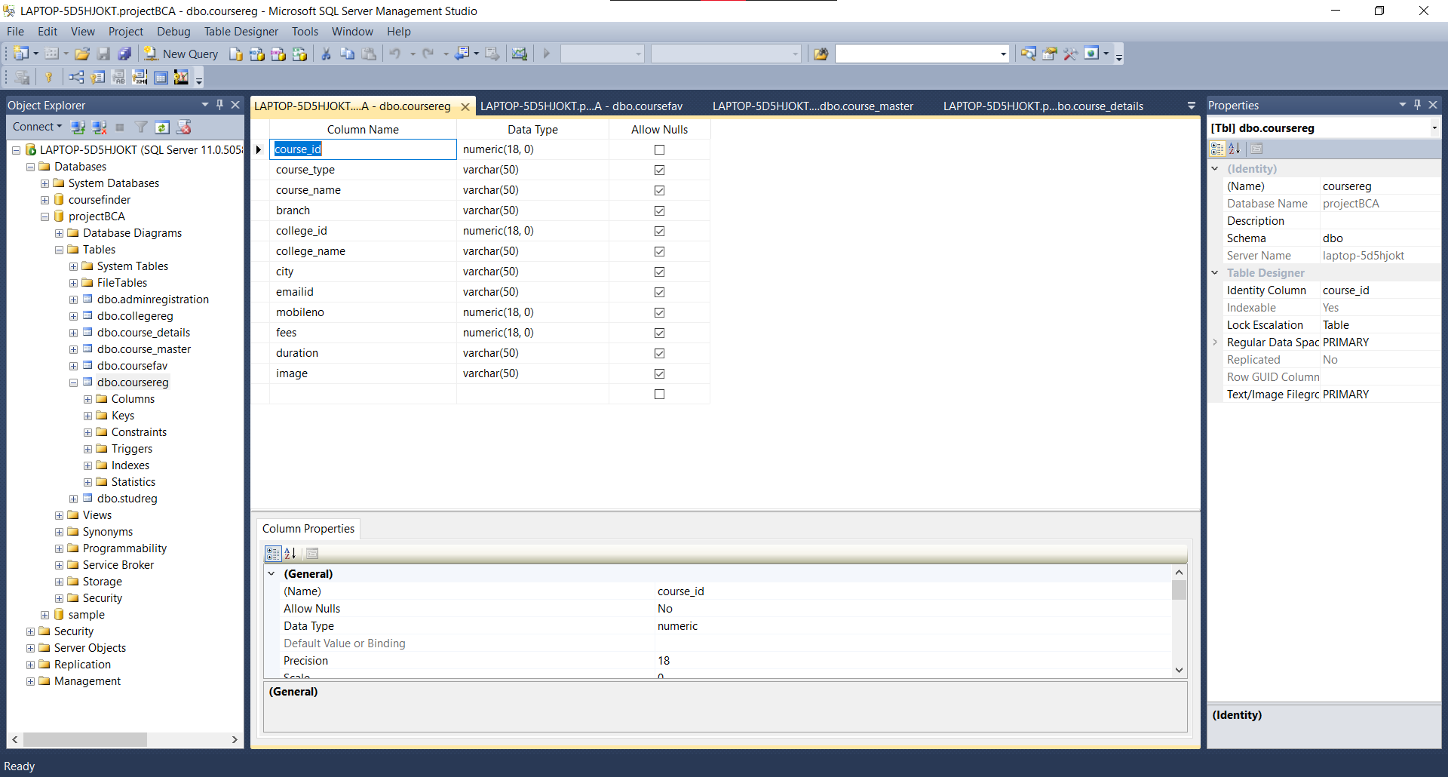

**6)Edit Course:**

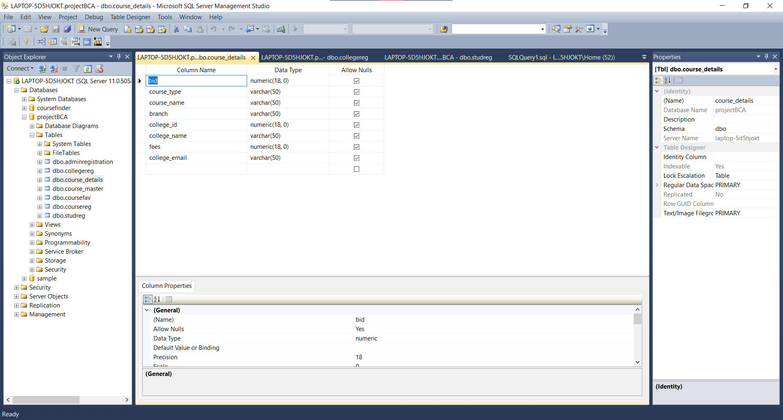

**7)Course Favorites Table:**

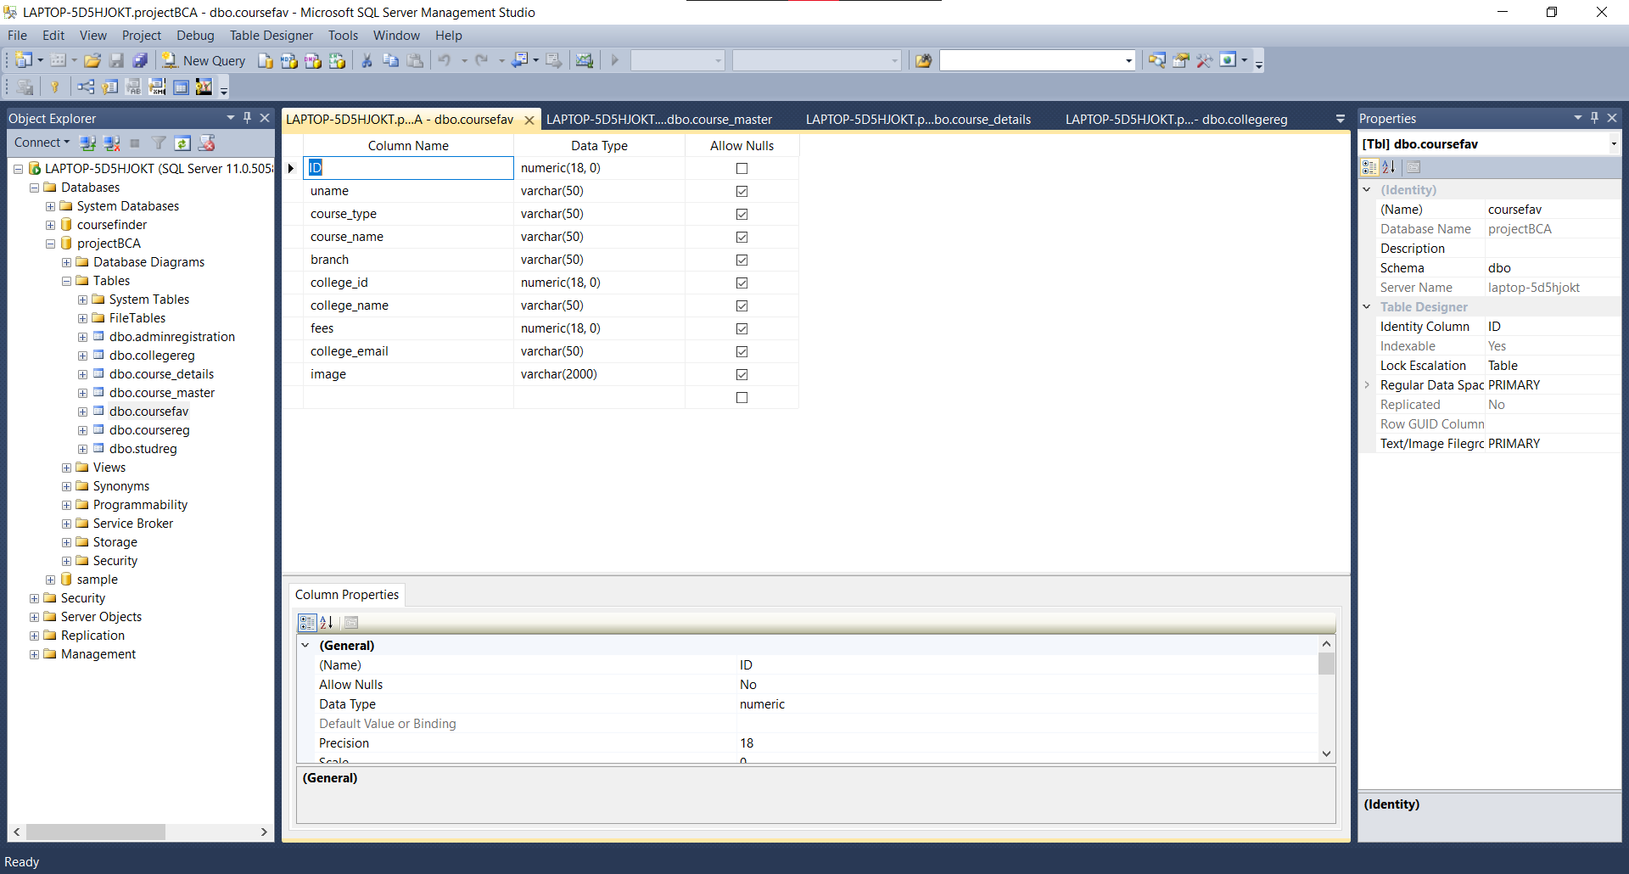

**SCREEN LAYOUT**

* **Login form:**

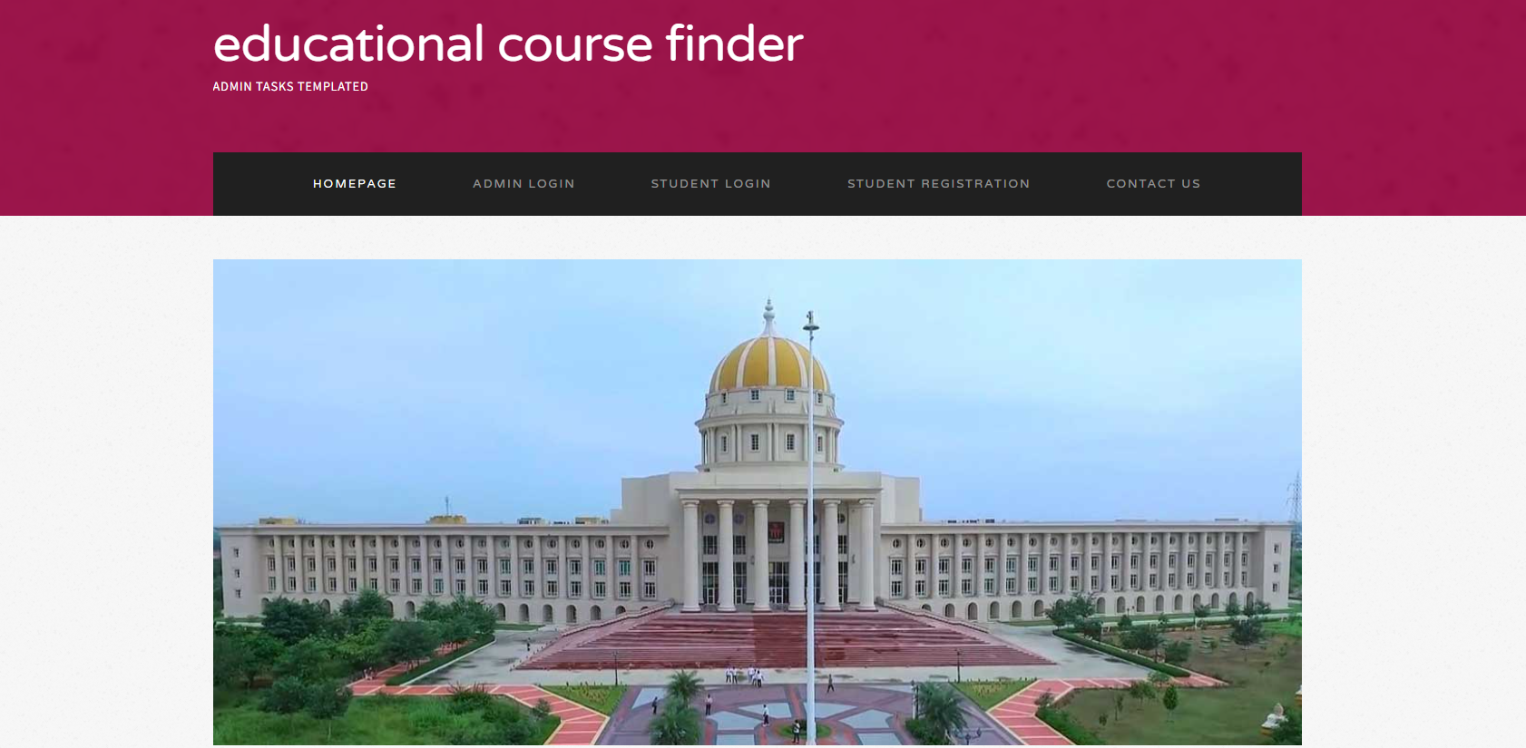

It is the Login form of the project in this login page user should login by providing Username and Password. If Username and Password are correctly provided by user then user can easily logged in. If Username or Password in incorrect then user will not be able to logged in.

* **Main Form:**

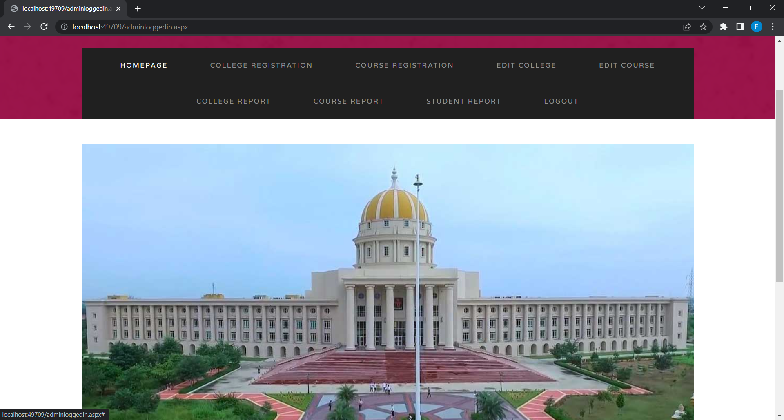

This is the main form in which there are different tasks are given .In this main form admin will register the student details and also college details .Where admin adds college, course details.

* **Student Registration Form:**

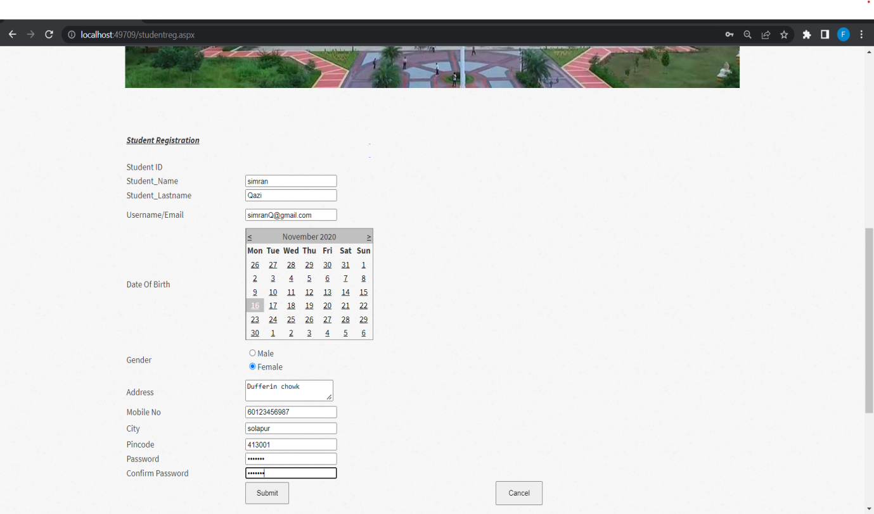

In the Student Registration form the admin has to fill the given necessary information and by clicking on the 'save' button all the information is saved in the database. If the admin wants to add new records then the user must click on 'new button. If admin wants to change some given details then he can just select the record and do the changes and click the 'update' button. If admin wants to delete given details he can just click on delete button. By clicking the exit' button the user can close the window. In the student registration form the student ID is auto generated.

**Student Login Form:**

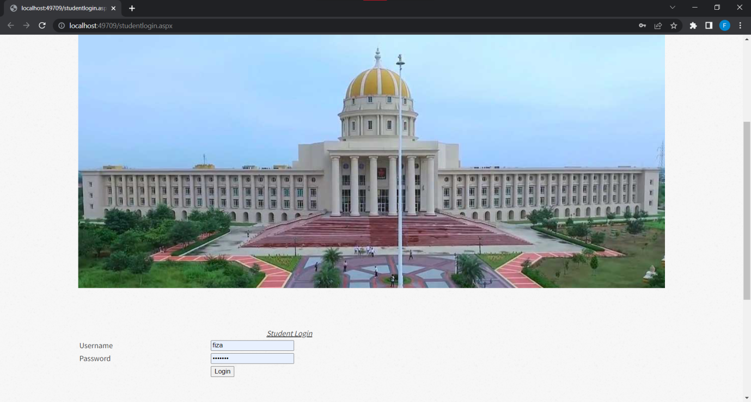

In the admin login form the admin has to login to make changes or insert information.

* **College Registration Form:**

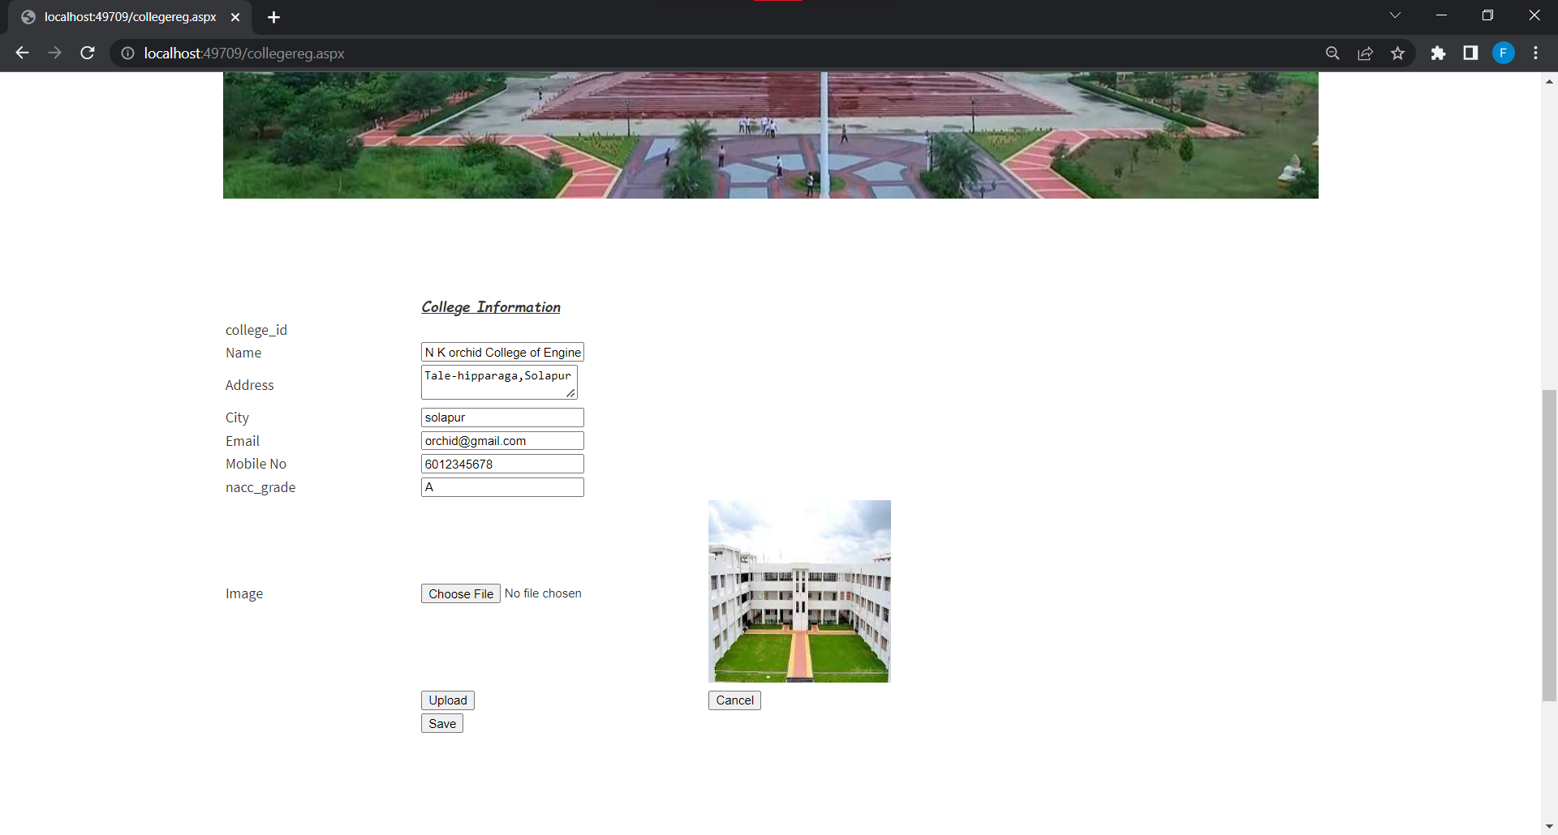

* **Course Registration:**

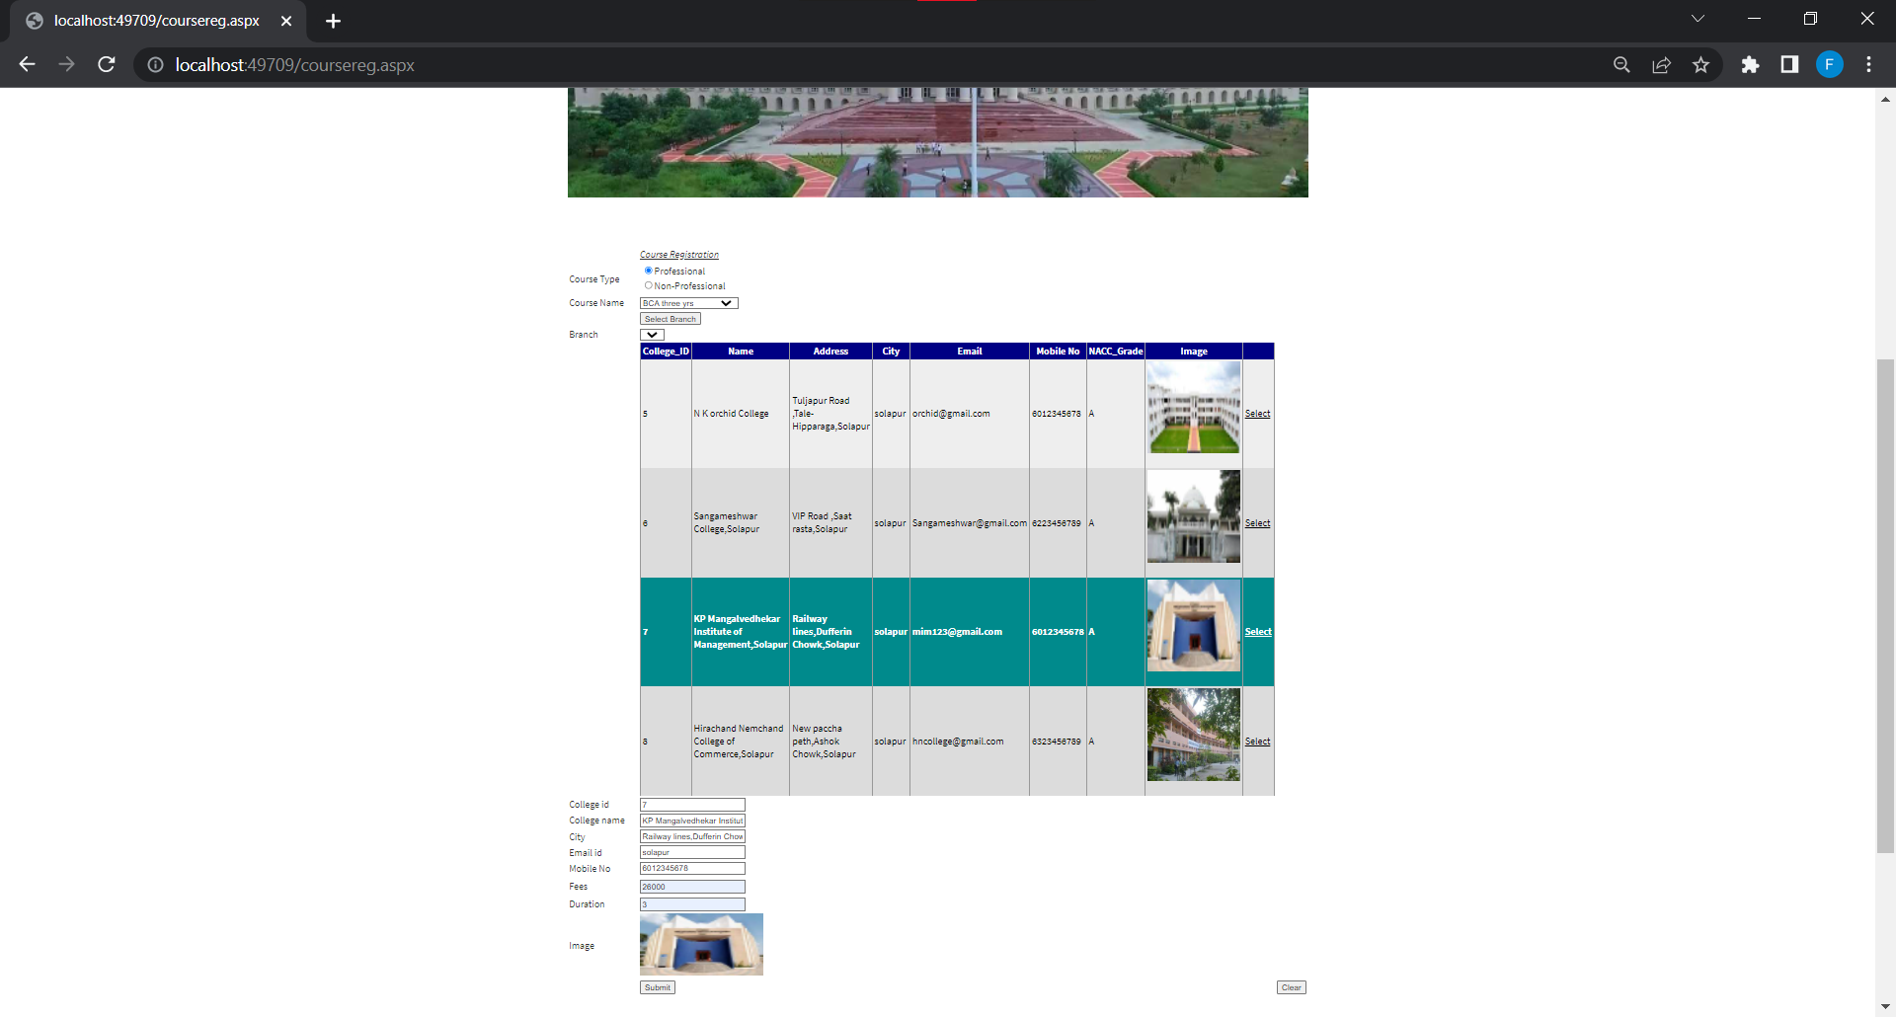

* **Edit College Form:**

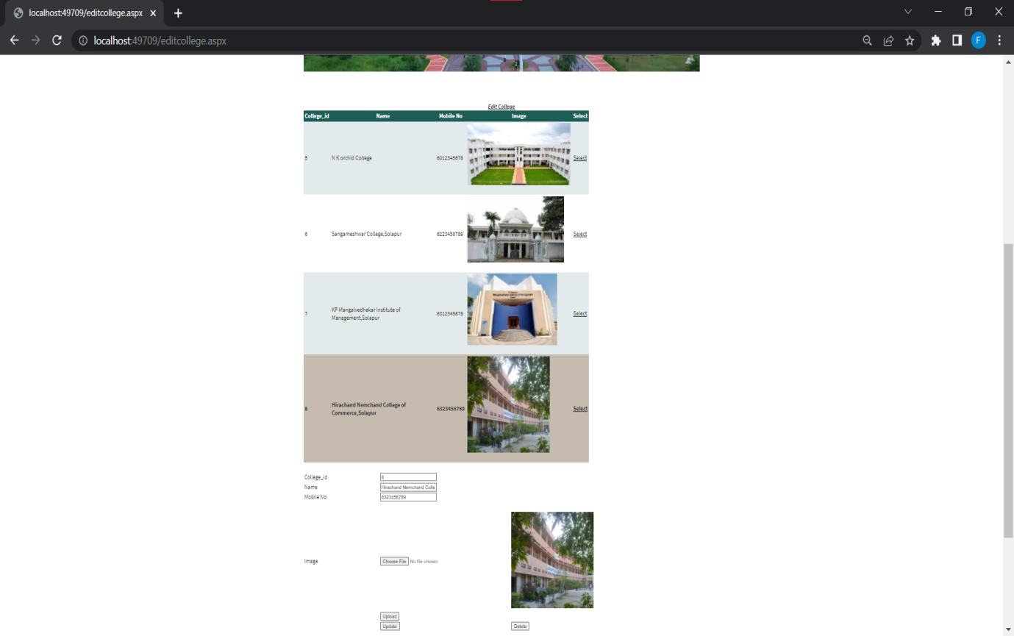

* **Edit Course Form:**

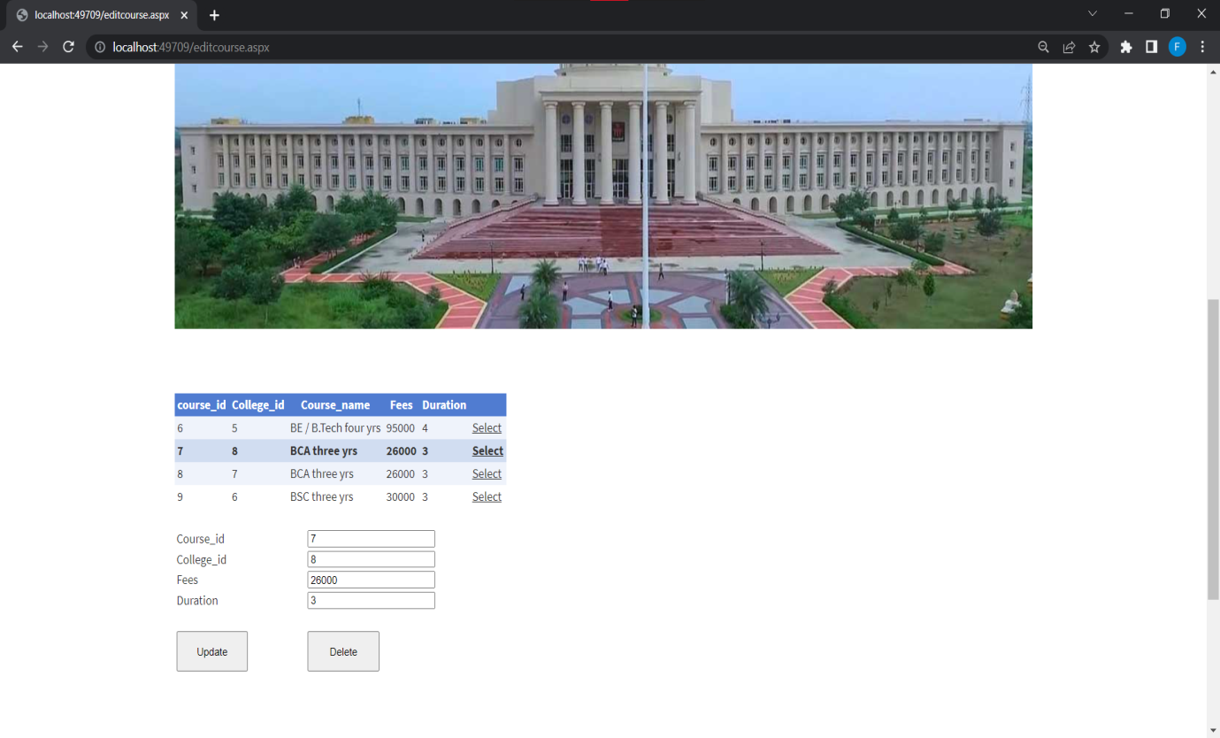

* **Favorites Course Form:**

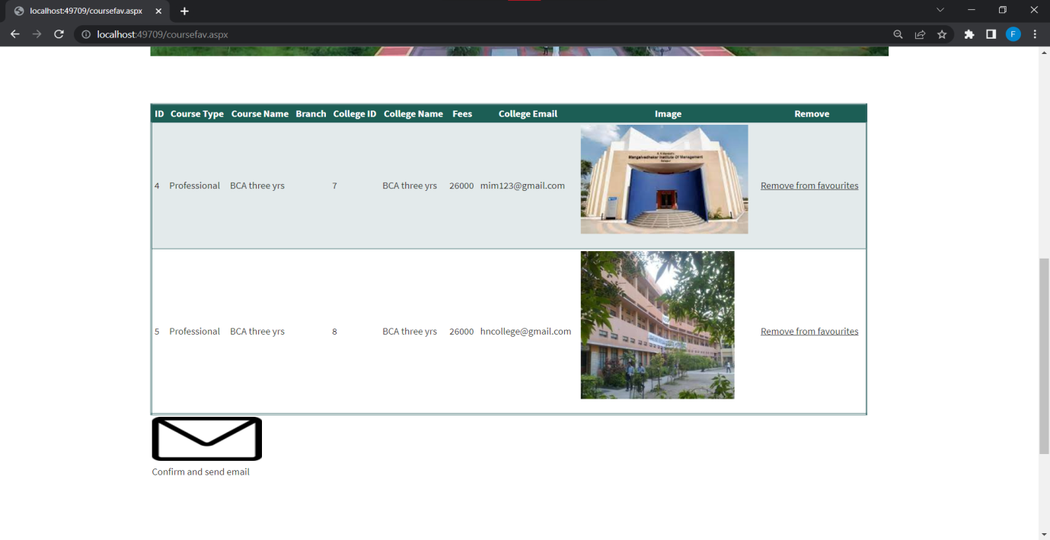

* **Select Course Form:**

**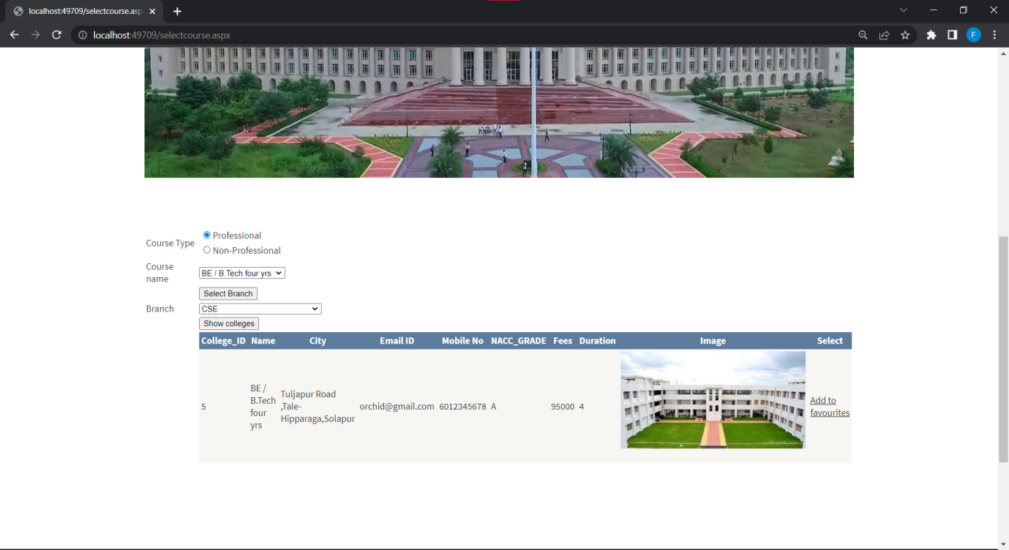*REPORTS***

* **College Registration Report:**

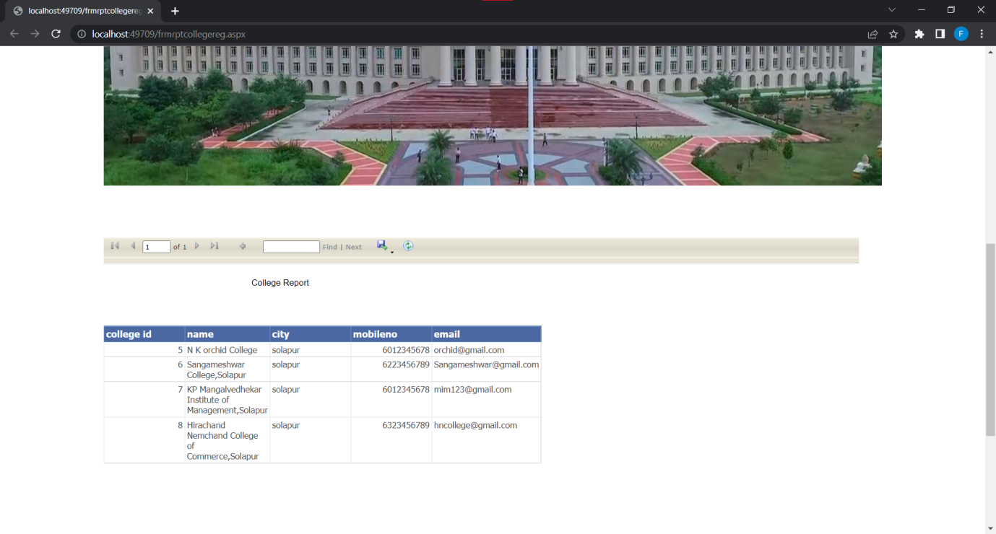

* **Course Registration Report:**

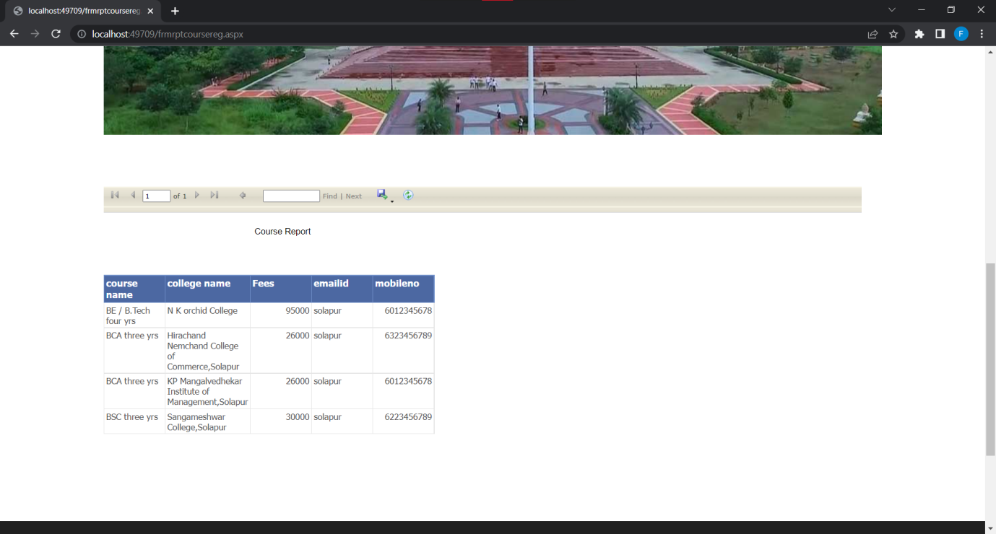

* **Student Registration Report:**

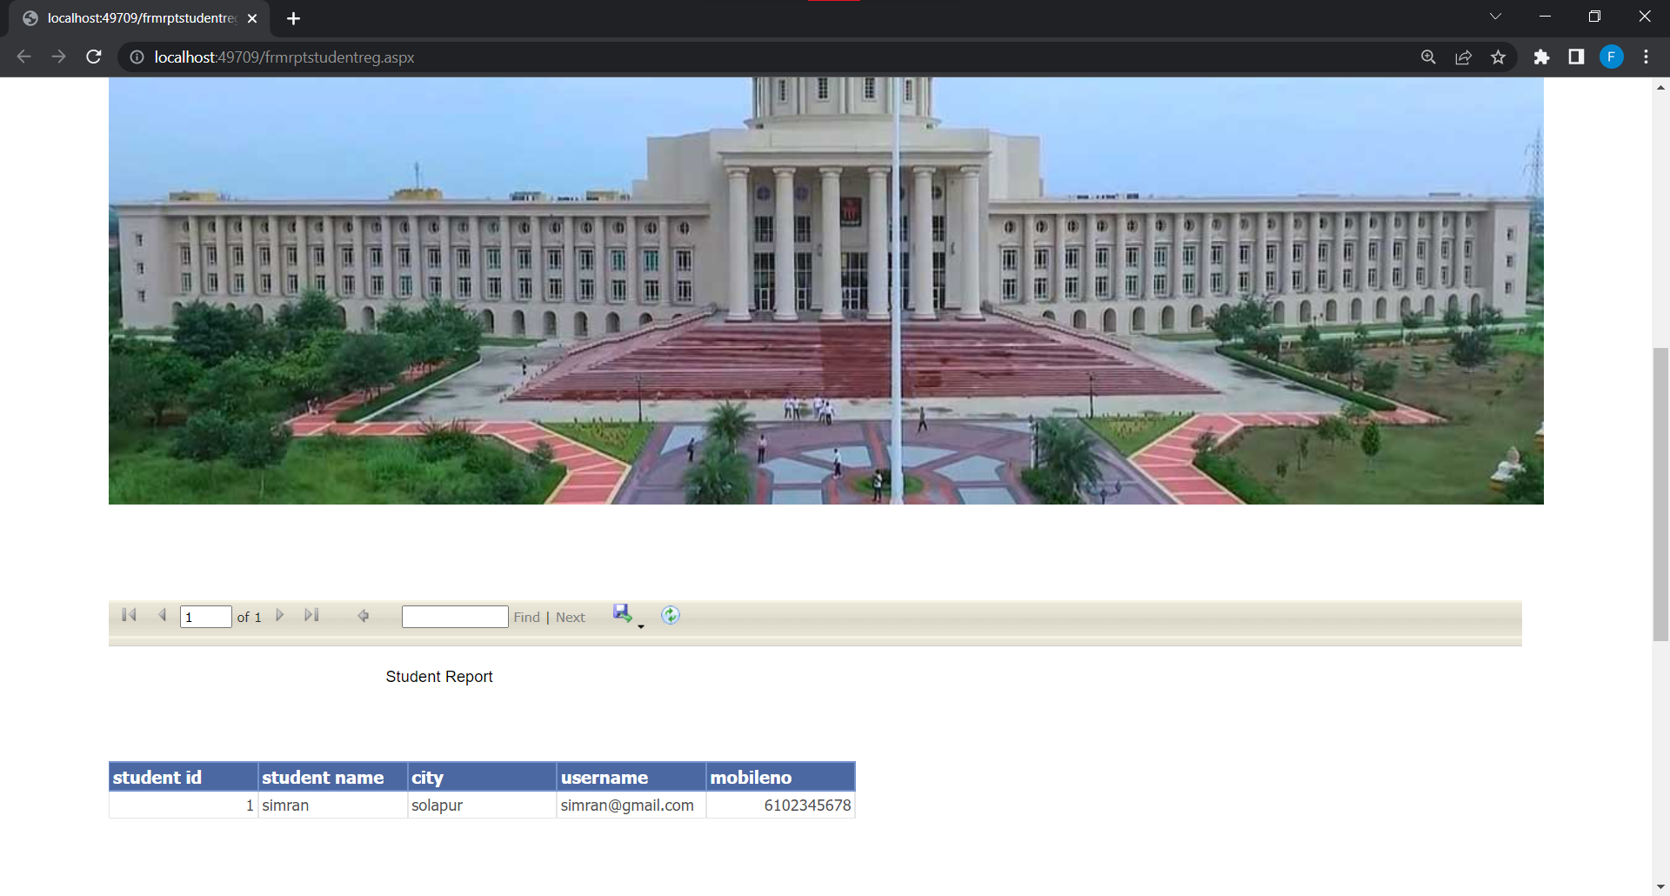

***TESTING***

Testing is the process of execution of the program with explicit intention of searching for errors. A successful test is one that reveals errors in the system. Test cases are devised with normal input. The data is created with the express intent of determining whether the system will process it in the correct & pre-planned orders Testing is a step, which is actual usage of the system to remove the various discrepancies present.

System is neither designed as entire system nor tested as single system System design, development, debugging and testing is carried out in modules . These modules are integrated to have entire fully fledged system.

**Unit Testing:**

In this testing the programs that form the system are tested. So this unit testing is also called "Program Testing". The unit testing focuses on various modules, independent of another to locate errors. This enables the tester to detect flaws, inabilities and errors in coding and the logic that are present with the module alone. The test cases are also needed to test the range of values that are including both valid and invalid data.

**System Testing:**

System testing checks for the integration of each module in the system. It also searches for the discrepancies between the system and its original objectives. Current specification , and system documentation. The primary concern is the compatibility of the individual modules.

**Actual Testing of System:**

The system is tested with these methods of testing. Testing is carried out using the test data and checked for discrepancies. The dummy data was provided in each & every possible way to ensure consistency of the system. The system with the validation at every stage handles all the data and also provides relevant message to the user in case of incorrect information.

**USER MANUAL**

**Login page:**

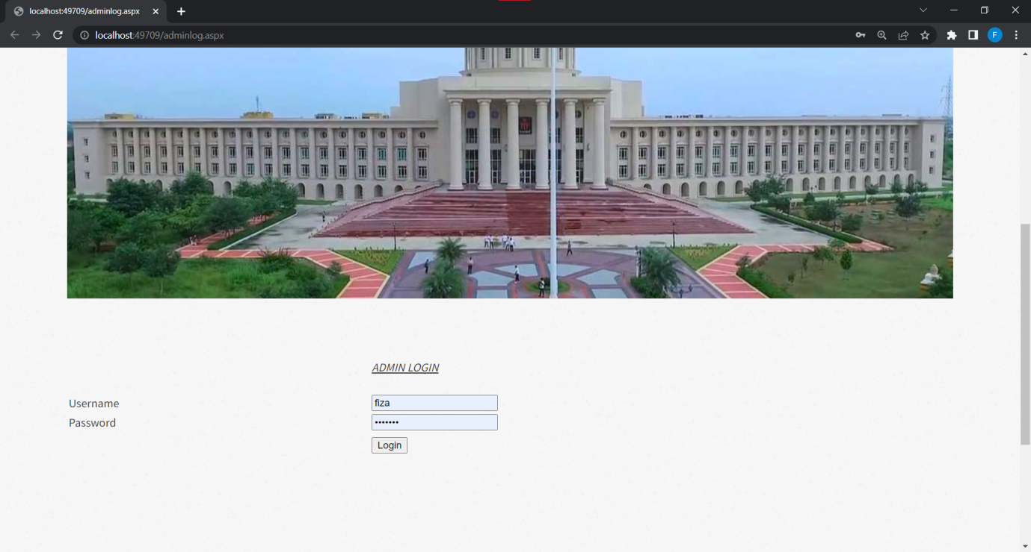

It can be used for signing in from the application. Depending up on the user role .i.e. Administrator or Dealer or Sales Person.

To login into system user must enter values of

* Username
* Password

**User Menu:**

* Admin Registration
* Student Registration
* College Registration
* Login Form
* Reports

**LIMITATIONS**

Although I have put my best efforts to make the software flexible, easy to operate but limitations cannot be ruled out even by me. Though the software presents a broad range of options to its users some intricate options could not be covered into it, partly because of logistic and partly due to lack of sophistication. Paucity of time was also major constraint, thus it was not possible to make the software foolproof and dynamic. Lack of time also compelled me to ignore some part such as storing old result of the candidate etc.

Considerable efforts have made the software easy to operate even for the people not related to the field of computers but it is acknowledged that a layman may find it a bit problematic at the first instance. The user is provided help at each step for his convenience in working with the software.

**Bibliography**

* The following website was referred during the preparation of their project.
* During the development of project we have use the following books and websites**.**

**1) Books:**

* The Complete reference ASP.Net-McDonald, Tata McGraw Hill.
* System Analysis and Design- Parthsarty .
* Database System Concepts :KorthSilberschetz.

**2) Website**

* [www.tutorialspoint.com](http://www.tutorialspoint.com)
* www.oracletutorial.com
* www.guru99.com
* [www.w3school.com](http://www.w3school.com)
* [www.google.com](http://www.google.com)